­­

**جمهورية العراق**

**وزارة التعليم العالي والبحث العلمي**

**جامعة واسط**

**كلية التربية للعلوم الصرفة**

**قسم علوم حاسوب**

**Design Application for Diet consults**

المشروع مقدم لغرض اكمال

متطلبات الحصول على شهادة البكالوريوس

**من قبل:**

**الاء عباس جواد**

**سكينه ناجي محسن**

**2023 - 2022**

**أشراف :**

**م.م علي عبد الكاظم**

بسم الله الرحمن الرحيم

**))** هُوَ الَّذِي بَعَثَ فِي الْأُمِّيِّينَ رَسُولًا مِّنْهُمْ يَتْلُو عَلَيْهِمْ آيَاتِهِ وَيُزَكِّيهِمْ وَيُعَلِّمُهُمُ الْكِتَابَ وَالْحِكْمَةَ وَإِن كَانُوا مِن قَبْلُ لَفِي ضَلَالٍ مُّبِينٍ **((**

صدق الله العظيم

**SUPERVISOR CERTIFICATION**

**I certify that the preparation of this project entitled (Design Application for Diet consults) prepared by (الاء عباس جواد , سكينه ناجي محسن) was under my supervision at College of Education for Pure Sciences, Computer Science Department, University of Wasit in partial fulfilment of the requirements for the degree of Bachelor of Education in Computer Science**

**Signature:**

**Supervisor Name:**

**Scientific Degree:**

**Date:**

**CERTIFICATE OF EXAMINERS**

We certify, as an examining committee, that we have read this project report entitled "Design Application for Diet consults**"** to examined the students (الاء عباس جواد, سكينه ناجي محسن**)** in its contents and found the project meets the standard for the degree of Bachelor of Education in Computer Science.

Signature: Signature:

Name: Name:

Date: Date:

Signature: Signature:

Name: Name:

Date: Date:

اهداء

نهدي تخرجنا إلى من كان دعائها سر نجاحنا وحنانها بلسم جراحنا إلى أغلى

الحبايب أمنا الحبيبة .

إلى سندنا وقوتنا وملاذنا بعد الله أبوينا.....

إلى من آثروننا على انفسهم .

إلى من أظهروا لنا ما هو أجمل من الحياة .

إلى من يجري حبهم في عروقنا إلى من ندين لهم بالكثير إخوتنا........

والى كل من ساهم في تلقيننا و لو بحرف في حياتنا الدراسية. والى اساتذتنا طول فترة دراستنا في الجامعة.

الشكر والتقدير

الشكر لله سبحانه و تعالى الذي وفقنا لأكتمال هذا البحث , والصلاة و السلام على المبعوث رحمة للعالمين و على اله و صحبه أجمعين . نتقدم بجزيل الشكر عظيم التقدير للاستاذ (**م.م علي عبد الكاظم**) و أن يمد له في وقته و أن يمد له في عمره , ولأدارة جامعة واسط / كليةالتربية /للعلوم الصرفة التي منحتنا الفرصة.

وايضا يتواصل الشكر لعمادة كلية التربية للعلوم الصرفة ,واساتذة القسم المحترمين والى زملائنا و زميلاتنا طول فترة مسيرتي الدراسية . وبالأخير الى قدوتنا

أبائنا و أمهاتنا أخوننا و اخواتنا .

**Abstract:**

The " Design Application for Diet consults" is a set of several principles and measures aimed at ensuring the safety and quality of food and preserving its health, and managing the nutritional and healthy diet through appropriate selection windows in a custom manner or choosing ready-made food and sports courses that have been added through control panels. The system is characterized by mass measurement features. The body to know its current status, and the system is distinguished by the powers of logging in to the site manager and users, and according to the different features available for each account type. The project was built in vb.net language, and data is stored in a SQL Server database.

**الملخص:**

" تصميم تطبيق لاستشارات النظام الغذائي " هو عبارة عن عدة مبادئ وتدابير تهدف إلى ضمان سلامة وجودة الغذاء والحفاظ على صحته, وادارة الحمية الغذائية والصحية من خلال نوافذ اختيار المناسب بشكل مخصص او اختيار الكورسات الغذائية ورياضية الجاهز والتي تم اضافتها من خلال لوحات تحكم ويمتاز النظام بمميزات قياس كتلة الجسم لمعرفة حالتة الحالية ويمتاز النظام بصلاحيات تسجيل الدخول لمدير الموقع و المستخدمين وباختلاف المميزات المتوفرة لكل نوع حساب و تم بناء المشروع بلغة vb.net و تخزين بيانات بقاعدة بيانات من نوع SQL Server.

**List of Contents**

Chapter One 1

Introduction 1

1

**1.1.** **Introduction:** 2

**1.2.** **Research Problem:** 3

**1.3.** **Research objectives:** 3

**1.4.** **Related Work:** 3

Chapter Two 5

Programming Software 5

5

**2-1 Overview:** 6

**2-2 VB.NET:** 6

**2-3 Variables:** 7

**2-4 Loops:** 7

**2-5 Loop Type Description** 7

**2-6 Arrays** 8

**2-7 Functions and Sub** 8

**2-8 SQL Server:** 9

**2-9 SQL standard and proprietary extensions:** 10

**2-10 SQL commands and syntax:** 11

Chapter Three 13

Methodology 13

**3.3. Users:** 14

**3.4. Meals:** 15

**3.5. Favorite Meals:** 16

**3.6. Dislike Meals:** 17

**3.7. Exercise course:** 17

**3.8. Information:** 18

**3.9. Meals Course:** 19

**3.10. Tips:** 20

Chapter Four 21

Implementation and Result 21

**4.1. Splash Screen:** 22

**4.2. Login Screen:** 22

**4.2. Registry Screen:** 23

**4.3. Main Menu:** 23

**4.4. Meals:** 24

**4.5. Tips:** 24

**4.6. Diet Manage:** 25

**4.7. Exercise Course Manage:** 25

**4.8. About:** 26

**4.9. User Dashboard:** 26

**4.10. Information:** 27

**4.11. Favorite Meals:** 27

**4.12. Dislike Meals:** 28

**4.13. Tips:** 28

**4.14. Exercise Course:** 28

**4.15. Meals Course:** 29

Chapter Five 30

Conclusion and Future Work 30

30

**Conclusion** 31

**Future Work** 31

References: 32

**List of Figures**

**Figure 1. Diagram** 14

**Figure 2 . Users** 15

**Figure 3. Users - Table Data** 15

**Figure 4. Meals** 15

**Figure 5 . Meals Data Table** 16

**Figure 6. Favorite Meals** 16

**Figure 7. Favorite Meals Table** 17

**Figure 8. Dislike Meals** 17

**Figure 9. Dislike Meals Data Table** 17

**Figure 10. Exercise course** 18

**Figure 11. Exercise course Data Table** 18

**Figure 12. Information** 19

**Figure 13. Information Data Table** 19

**Figure 14. Meals Course** 19

**Figure 15. Meals course Data Table** 20

**Figure 16. Tips** 20

**Figure 17. Tips Data Table** 20

**Figure 18. Splash Screen** 22

**Figure 19. Login Screen** 22

**Figure 20 . Registration** 23

**Figure 21. Main Menu** 23

**Figure 22. Products** 24

**Figure 23. Tips** 24

**Figure 24. Meals Course Manage** 25

**Figure 25. Exercise Course Manage** 25

**Figure 26. About** 26

**Figure 27 . User Dashboard** 26

**Figure 28 . Information** 27

**Figure 29 . Favorite Meals** 27

**Figure 30 . Dislike Meals** 28

**Figure 31 . Tips** 28

**Figure 32 . Exercise Course** 29

**Figure 33 . Meals Course** 29

Chapter One

Introduction

* 1. **Introduction:**

Dieting is a change in eating pattern that is followed for various health purposes. The primary purposes of a diet can be weight loss, excess fat removal, improvement of general health, and improvement of the functioning of the digestive system. Diets are based on a variety of foods, which have different benefits for human health.

Diets can vary according to desired goals and the type of foods that are included in them. The most common types of diets are the keto diet, the vegan diet, the metretrain diet, and the balanced diet. These diets differ in the type of foods that are eaten and the nutritional components that are included in them.

In addition to diets, there is also a diet that is applied in the long term. The diet includes foods and drinks that are consumed throughout the day, and aims to provide the nutritional values necessary for human health. A well-balanced diet can have many health benefits, such as improved digestion and metabolism, improved energy and activity levels, improved general health and disease prevention.

Improve body mass index and get rid of excess fat, as well as reduce cholesterol and blood sugar levels. It can also help prevent chronic diseases such as heart disease, diabetes and cancer, improve digestive health and promote overall well-being and a sense of well-being and activity.

Despite the great benefits of diets and a balanced diet, it is important to take care of the balance of foods and not to overeat any type of food in large quantities. It should also ensure that all nutrients necessary for a healthy body are provided, including proteins, carbohydrates, fats, vitamins, minerals and fibre.

* 1. **Research Problem:**

1- Many people suffer from paying the costs of sports and health courses because of their high cost, difficulty in managing appropriate diets, determining preferred and unfavorable meals, healthy nutritional courses and exercise to build a harmonious body.

2- difficulty in calculating the appropriate weight for the user and knowing the appropriate weight and physical condition of the user in whether he is This user is fat, weak, acceptable, etc.

* 1. **Research objectives:**

The application provides complete management through the control panels of the application manager. Meals, sports and nutritional courses, useful advice are managed, appropriate diets are managed, preferred and unfavorable meals are determined, healthy food courses and exercise to build a harmonious body, the possibility of calculating the appropriate weight for the user and knowing the appropriate weight and physical condition of the user in what If this user is fat, weak or acceptable.

* 1. **Related Work:**

1. Mark Ryan, “The ethics of dietary apps: Technology, health, and the capability approach‏”, Dietary apps are said to promote better eating habits, improve dietary knowledge, and awareness about nutrition. However, their use has also raised a number of ethical and social issues related to their impact on individual freedoms, for creating power asymmetries, restricting end-users from expanding their knowledge of health, nudging individuals, and even having harmful effects on people’s health. Wageningen University, 2022[1].
2. Mirey Karavetian, “The Effects of Dietary Mobile Apps on Nutritional Outcomes in Adults with Chronic Diseases: A Systematic Review and Meta-Analysis”, Dietary interventions are effective prevention and treatment strategies for chronic diseases; however, they require extensive commitment, time, and resources. Dietary mobile applications (apps) have gained popularity and are thus being incorporated into dietary management. 2019 [2].
3. Madison Milne-Ives, “Mobile Apps for Health Behavior Change in Physical Activity, Diet, Drug and Alcohol Use, and Mental Health” With a growing focus on patient interaction with health management, mobile apps are increasingly used to deliver behavioral health interventions. The large variation in this mobile health apps-their target patient group, health behavior, and behavioral change strategies—has resulted in a large but incohesive body of literature.2020.[3]
4. Amanda Cuevas-Sierra, “Diet, Gut Microbiota, and Obesity: Links with Host Genetics and Epigenetics and Potential Applications”, Diverse evidence suggests that the gut microbiota is involved in the development of obesity and associated comorbidities. It has been reported that the composition of the gut microbiota differs in obese and lean subjects, suggesting that microbiota dysbiosis can contribute to changes in body weight. However, the mechanisms by which the gut microbiota participates in energy homeostasis are unclear. Gut microbiota can be modulated positively or negatively by different lifestyle and dietary factors. 2019.[4]
5. Abbie Fewings, “The use and acceptability of diet-related apps and websites in Australia”, Diet-related apps and websites are developed to help improve dietary intake. The aim of this study is to explore the use and acceptability of diet-related apps and websites in Australia. 2022 [5]

Chapter Two

Programming Software

**2-1 Overview:**

There are many programming languages and we chose the Visual Basic language for ease of learning and use, so that the maintenance process is faster and better, and the benefits of using SQL for the possibility of carrying very large data without limits.

**2-2 VB.NET:**

Visual Basic, originally called Visual Basic .NET (VB.NET), is a multi-paradigm, object-oriented programming language, implemented on .NET, Mono, and the .NET Framework. Microsoft launched VB.NET in 2002 as the successor to its original Visual Basic language, the last version of which was Visual Basic 6.0. Although the ".NET" portion of the name was dropped in 2005, this article uses "Visual Basic [.NET]" to refer to all Visual Basic languages released since 2002, in order to distinguish between them and the classic Visual Basic. Along with C# and F#, it is one of the three main languages targeting the .NET ecosystem. As of March 11, 2020, Microsoft announced that evolution of the VB.NET language has concluded.

Microsoft's integrated development environment (IDE) for developing in Visual Basic is Visual Studio. Most Visual Studio editions are commercial; the only exceptions are Visual Studio Express and Visual Studio Community, which are freeware. In addition, the .NET Framework SDK includes a freeware command-line compiler called vbc.exe. Mono also includes a command-line VB.NET compiler.

Visual Basic is often used in conjunction with the Windows Forms GUI library to make desktop apps for Windows. Programming for Windows Forms with Visual Basic involves dragging and dropping controls on a form using a GUI designer and writing corresponding code for each control.

**2-3 Variables:**

A variable is nothing but a name given to a storage area that our programs can manipulate. Each variable in VB.Net has a specific type, which determines the size and layout of the variable's memory; the range of values that can be stored within that memory; and the set of operations that can be applied to the variable.

**2-4 Loops:**

There may be a situation when you need to execute a block of code several number of times. In general, statements are executed sequentially: The first statement in a function is executed first, followed by the second, and so on. Programming languages provide various control structures that allow for more complicated execution paths. A loop statement allows us to execute a statement or group of statements multiple times and following is the general form of a loop statement in most of the programming languages.

**2-5 Loop Type Description**

Do Loop It repeat the enclosed block of statements while a Boolean condition is True or until the condition becomes True. It could be terminated at any time with the Exit Do Statement For...Next It repeats a group of statements a specified number of times and a loop index counts the number of loop iterations as the loop executes.

For Each...Next

It repeats a group of statements for each element in a collection. This loop is used for accessing and manipulating all elements in an array or a VB.Net collection.

* While... End While It executes a series of statements as long as a given
* condition is True.
* With... End with It is not exactly a looping construct. It executes a series
* of statements that repeatedly refer to a single object or
* structure.
* Nested loops You can use one or more loops inside any another
* While, For or Do loop.

**2-6 Arrays**

An array stores a fixed-size sequential collection of elements of the same type. An array is used to store a collection of data, but it is often more useful to think of an array as a collection of variables of the same type.

All arrays consist of contiguous memory locations. The

lowest address corresponds to the first element and the highest address to the last element.

For example,

1. Dim intData(30) ' an array of 31 elements
2. Dim strData(20) As String ' an array of 21 strings
3. Dim twoDarray(10, 20) As Integer 'a two dimensional
4. array of integers
5. Dim ranges(10, 100) 'a two dimensional array

**2-7 Functions and Sub**

A procedure is a group of statements that together perform a task when called. After the procedure is executed, the control returns to the statement calling the procedure. VB.Net has two types of procedures −

1- Functions

2- Sub procedures or Subs

Note: Functions return a value, whereas Subs do not return a value

**2-8 SQL Server:**

Structured Query Language (SQL) is a standardized programming language that is used to manage [relational databases](https://searchdatamanagement.techtarget.com/definition/relational-database) and perform various operations on the data in them. Initially created in the 1970s, SQL is regularly used not only by database administrators, but also by developers writing data integration scripts and data analysts looking to set up and run analytical queries.

The term *SQL* is pronounced *less-Kew-ell*or *sequel*.

SQL is used for the following:

* modifying database table and index structures;
* adding, updating and deleting rows of data; and
* retrieving subsets of information from within relational database management systems ([RDBMSes](https://searchdatamanagement.techtarget.com/definition/RDBMS-relational-database-management-system)) -- this information can be used for transaction processing, analytics applications and other applications that require communicating with a relational database.

SQL queries and other operations take the form of commands written as statements and are aggregated into programs that enable users to add, modify or retrieve data from database tables.

A table is the most basic unit of a database and consists of rows and columns of data. A single table holds records, and each record is stored in a row of the table. Tables are the most used type of database objects, or structures that hold or reference data in a relational database. Other types of database objects include the following:

* **Views** are logical representations of data assembled from one or more database tables.
* **Indexes** are lookup tables that help speed up database lookup functions.
* **Reports** consist of data retrieved from one or more tables, usually a subset of that data that is selected based on search criteria.

Each column in a table corresponds to a category of data -- for example, customer name or address -- while each row contains a data value for the intersecting column.

Relational databases are relational because they are composed of tables that relate to each other. For example, a SQL database used for customer service can have one table for customer names and addresses and other tables that hold information about specific purchases, product codes and customer contacts. A table used to track customer contacts usually uses a unique customer identifier called a *key* or [*primary key*](https://searchsqlserver.techtarget.com/definition/primary-key) to reference the customer's record in a separate table used to store customer data, such as name and contact information.

SQL became the de facto standard programming language for relational databases after they emerged in the late 1970s and early 1980s.

**2-9 SQL standard and proprietary extensions:**

An official SQL standard was adopted by the American National Standards Institute ([ANSI](https://www.techtarget.com/searchdatacenter/definition/ANSI)) in 1986, with the International Organization for Standardization ([ISO](https://www.techtarget.com/searchdatacenter/definition/ISO)) adopting the standard in 1987. New versions of the SQL standard are published every few years, the most recent in 2016.

ISO/IEC 9075 is the ISO SQL standard developed jointly by ISO and the International Electrotechnical Commission. The standard way of referring to an ISO standard version is to use the standards organizations -- ISO/IEC -- followed by the ISO standard number, a colon and the publication year. The current ISO standard for SQL is ISO/IEC 9075:2016.

Both proprietary and open source RDBMSes built around SQL are available for use by organizations. SQL-compliant database server products include the following:

* [Microsoft SQL Server](https://searchdatamanagement.techtarget.com/definition/SQL-Server)
* Oracle Database
* IBM [Db2](https://searchdatamanagement.techtarget.com/definition/Db2)
* SAP HANA
* SAP Adaptive Server
* Oracle [MySQL](https://searchoracle.techtarget.com/definition/MySQL)
* open source [PostgreSQL](https://whatis.techtarget.com/definition/PostgreSQL)

Some versions of SQL include proprietary extensions to the standard language for procedural programming and other functions. For example, Microsoft offers a set of extensions called [Transact-SQL](https://searchdatamanagement.techtarget.com/definition/T-SQL), while Oracle's extended version of the standard is [Procedural Language for SQL](https://searchoracle.techtarget.com/definition/PL/SQL). Commercial vendors offer proprietary extensions to differentiate their product offerings by giving customers additional features and functions. As a result, the different variants of extended SQL offered by vendors are not fully compatible with one another.

**2-10 SQL commands and syntax:**

SQL is, fundamentally, a programming language designed for accessing, modifying and extracting information from relational databases. As a programming language, SQL has commands and a syntax for issuing those commands.

SQL commands are divided into several different types, including the following:

* **Data Definition Language (**[**DDL**](https://whatis.techtarget.com/definition/Data-Definition-Language-DDL)**)**commands are also called *data definition commands* because they are used to define data tables.
* **Data Manipulation Language (DML)**commands are used to manipulate data in existing tables by adding, changing or removing data. Unlike DDL commands that define how data is stored, DML commands operate in the tables defined with DDL commands.
* **Data Query Language** consists of just one command, SELECT, used to get specific data from tables. This command is sometimes grouped with the DML commands.
* **Data Control Language** commands are used to grant or revoke user access privileges.
* **Transaction Control Language** commands are used to change the state of some data -- for example, to COMMIT transaction changes or to ROLLBACK transaction changes.

SQL syntax, the set of rules for how SQL statements are written and formatted, is similar to other programming languages. Some components of SQL syntax include the following:

* SQL statements start with a SQL command and end with a semicolon (**;**), for example:

SELECT * FROM customers;

This SELECT statement extracts all of the contents of a table called customers.

Chapter Three

Methodology

**3.1. Overview:**

This chapter contains the diagram of the project, which is a formal scheme that shows all the tables and data in the project, the relationships that connect the tables and the keys used, in addition to an explanation about them.

**3.2. Database:**

The system contains a database of SQL type containing 9 tables and linked with some of the table's basic function is to store certain data inside it to be displayed when needed.

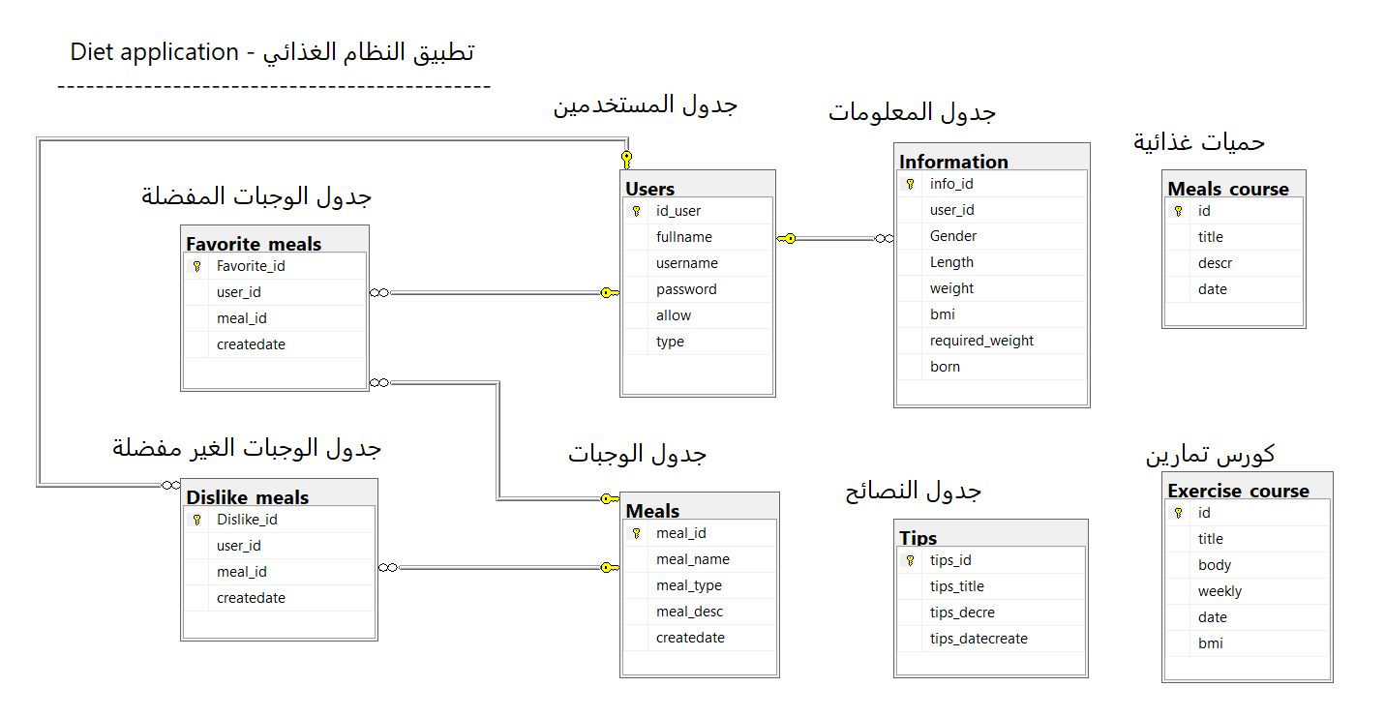

**Figure 1. Diagram**

**3.3. Users:**

It is the table responsible for storing all user data in the program and for the login process to prevent the use of the program by people who are not allowed to do so.

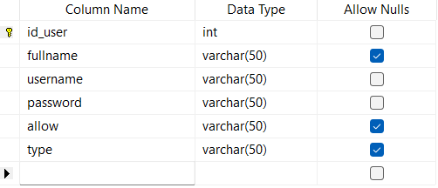

**Figure 2 . Users**

Table Data

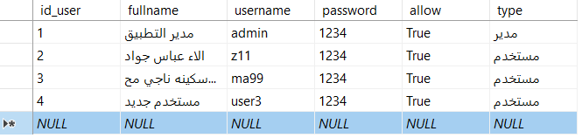

**Figure 3. Users - Table Data**

**3.4. Meals:**

The storage of all Meals data, such as Meal number, name, type, description, date of addition, is managed.

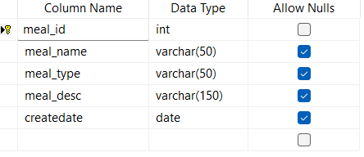

**Figure 4. Meals**

Table Data

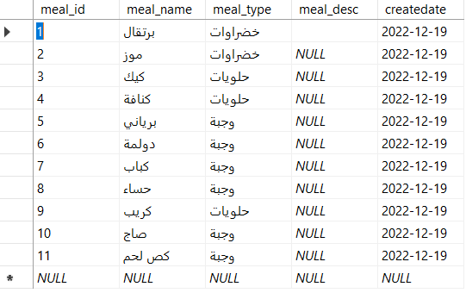

**Figure 5 . Meals Data Table**

**3.5. Favorite Meals:**

In this table, data for preferred meals is stored by storing the meal number, user number, and date of addition.

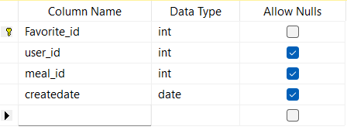

**Figure 6. Favorite Meals**

Table Data

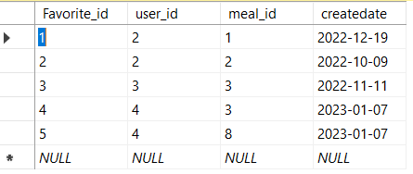

**Figure 7. Favorite Meals Table**

**3.6. Dislike Meals:**

In this table, data for unpreferred meals is stored by storing the meal number, user number, and date of addition.

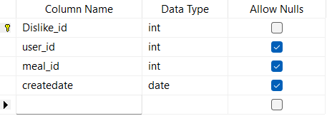

**Figure 8. Dislike Meals**

Table Data

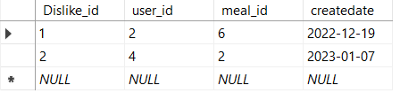

**Figure 9. Dislike Meals Data Table**

**3.7. Exercise course:**

In this table, the sports course data is stored by storing the meal number and the sports course number.

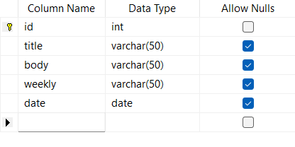

**Figure 10. Exercise course**

Table Data

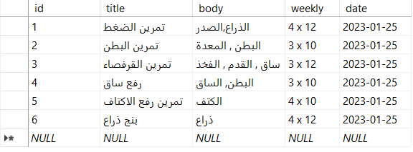

**Figure 11. Exercise course Data Table**

**3.8. Information:**

In this table, additional user data such as gender, height, weight, births, and body mass value are stored to know the user's physical condition.

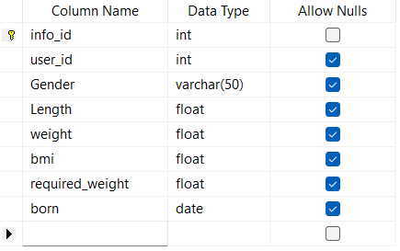

**Figure 12. Information**

Table Data

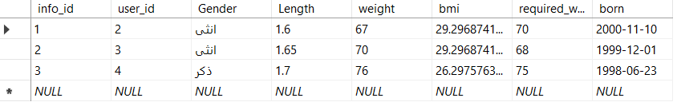

**Figure 13. Information Data Table**

**3.9. Meals Course:**

In this table, the course data is stored, such as the title, description, and date of addition.

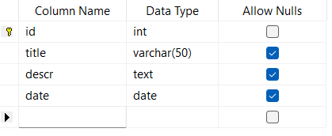

**Figure 14. Meals Course**

Table Data

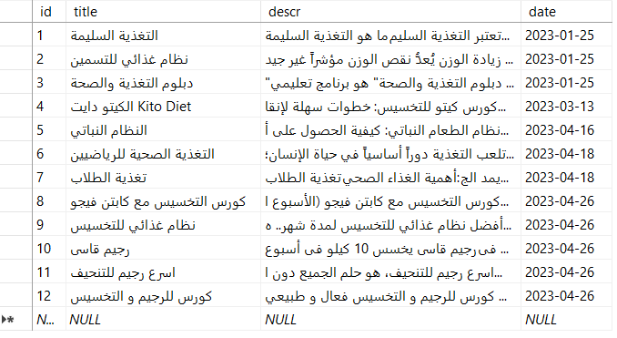

**Figure 15. Meals course Data Table**

**3.10. Tips:**

In this table, nutritional advice data is stored, such as the title of the advice, the description of the advice, and the date added.

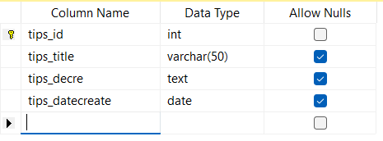

**Figure 16. Tips**

Table Data

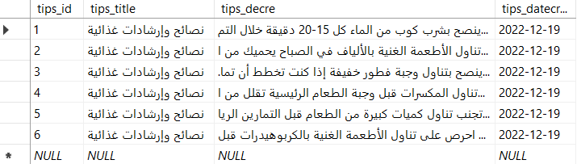

**Figure 17. Tips Data Table**

Chapter Four

Implementation and Result

**4.1. Splash Screen:**

Welcome window: This is the first window that appears when you launch the program. It has a progress bar, which is a counter that automatically increments when the counter value becomes 100. The window closes and the next window opens, which is the login window.

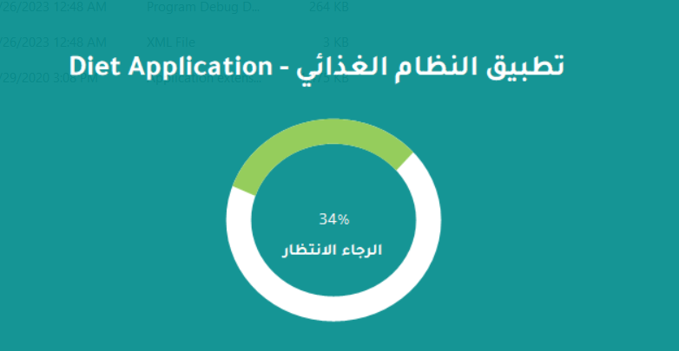

**Figure 18. Splash Screen**

**4.2. Login Screen:**

The login window The system asks for a username and password to prevent unauthorized persons from entering the system using the program and tampering with data.

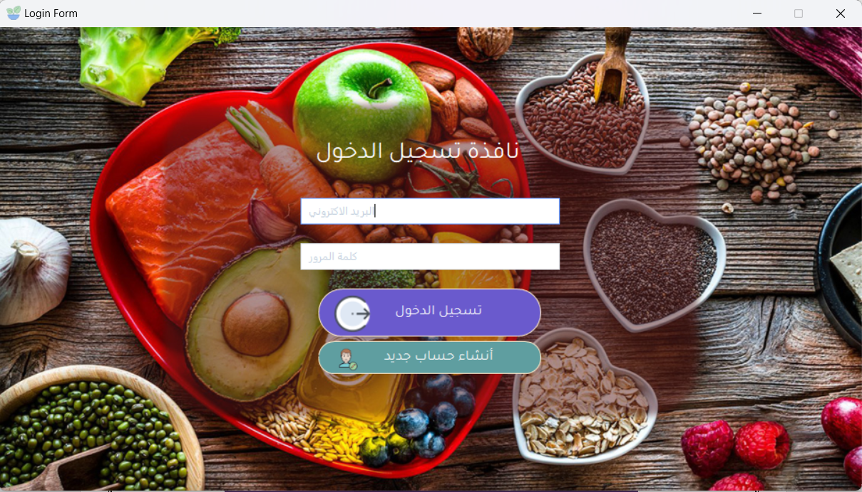

**Figure 19. Login Screen**

**4.2. Registry Screen:**

In this window, a new user is created by filling in the required data. 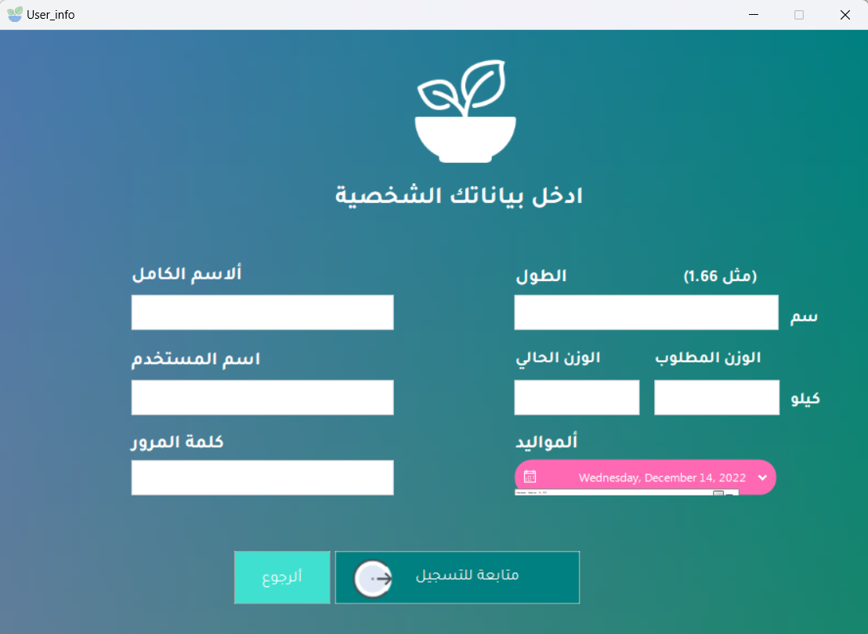

**Figure 20 . Registration**

**4.3. Main Menu:**

We can access any of the windows of the project through this window, and it is considered one of my favorite windows through which we can register to exit the program.

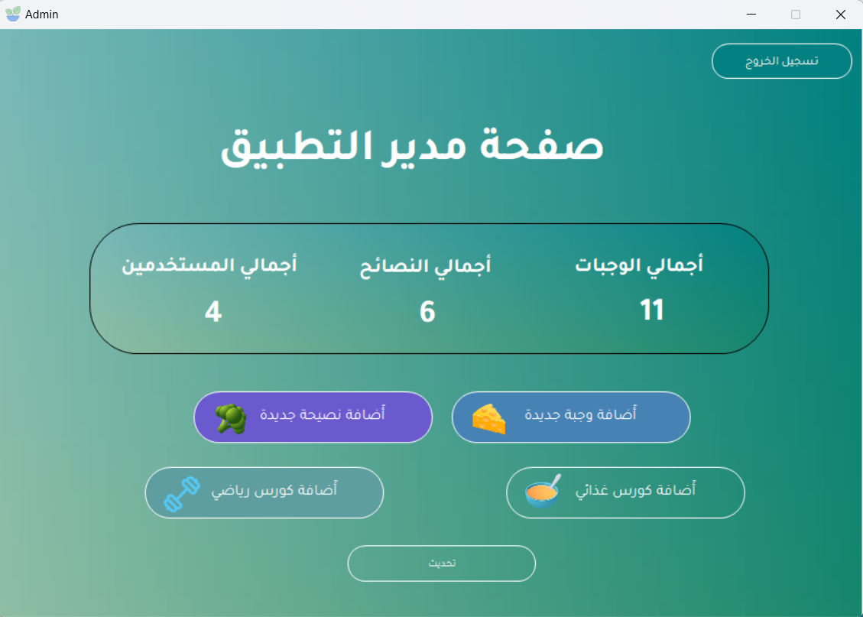

**Figure 21. Main Menu**

**4.4. Meals:**

In this window, we can manage all Meals data, such as displaying products, adding a new Meals, modifying it, and deleting the Meals with ease, You can add new Meals to the database, modify data, or delete the Meals.

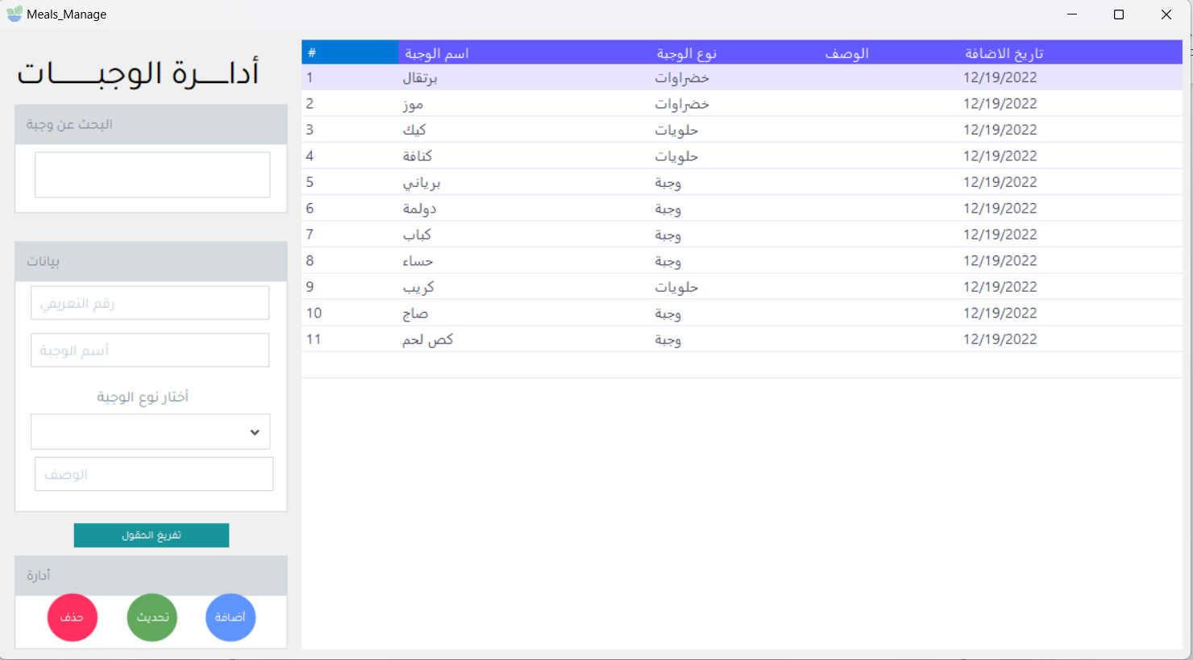

**Figure 22. Products**

**4.5. Tips:**

In this window, advice data is managed by entering the advice title and advice description, and the date is recorded automatically.

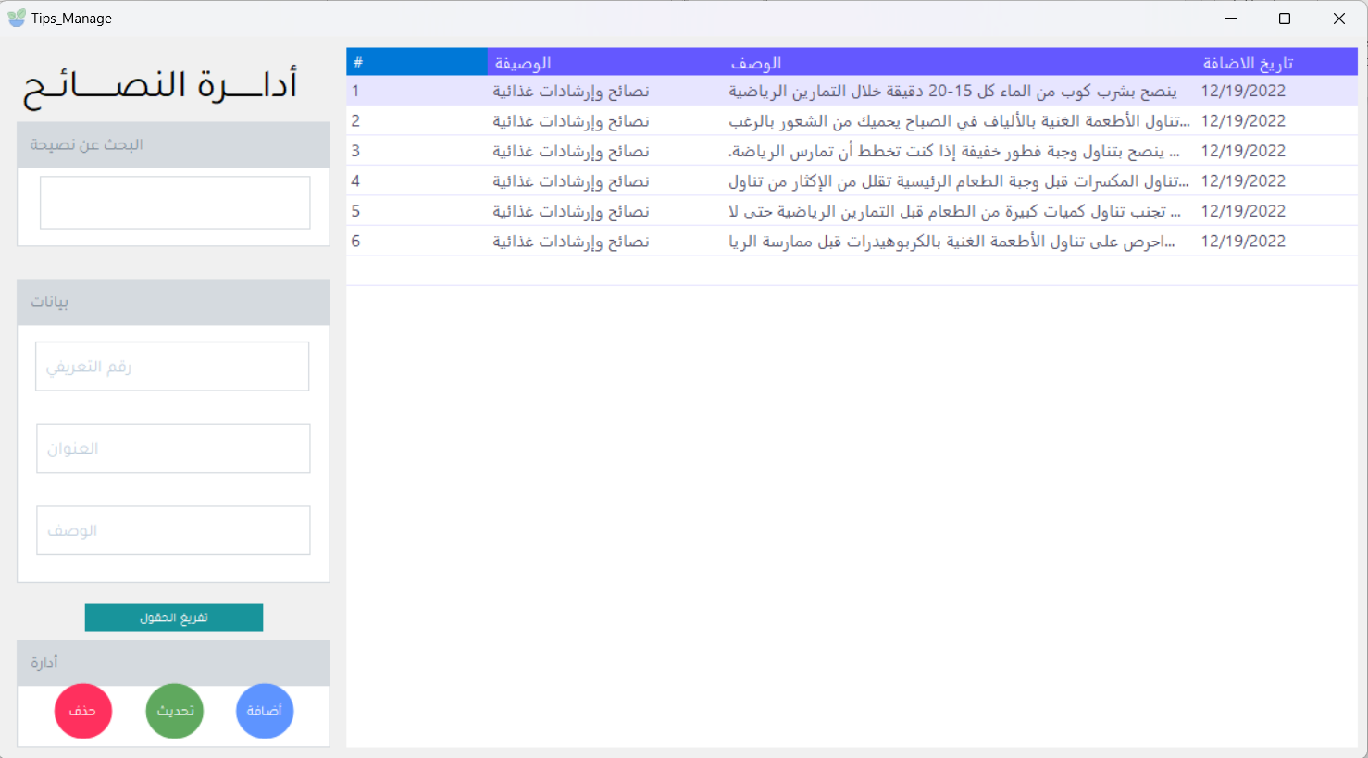

**Figure 23. Tips**

**4.6. Diet Manage:**

In this window, the food course data is managed by filling in the required course data, such as the course title and its description.

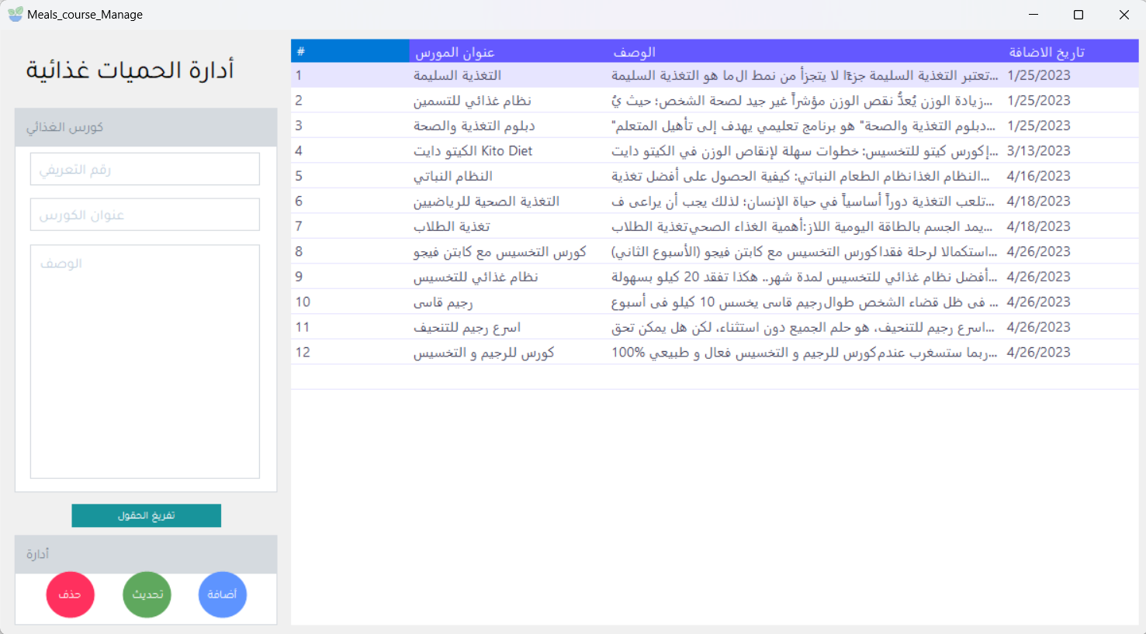

**Figure 24. Meals Course Manage**

**4.7. Exercise Course Manage:**

In this window, the sports course data is managed by filling in the required course data, such as the course title, body part, and repetition.

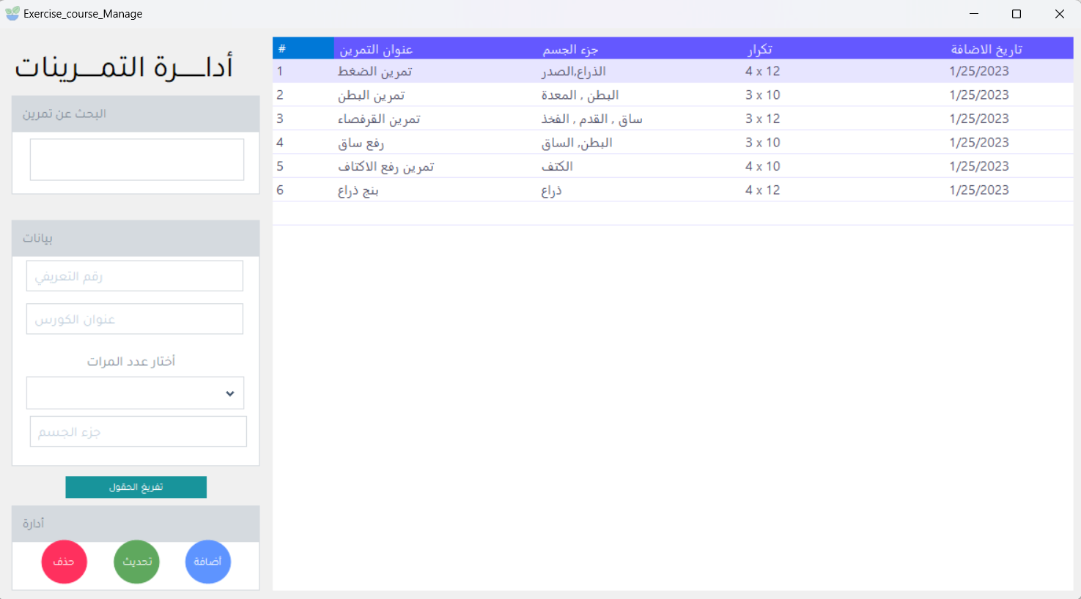

**Figure 25. Exercise Course Manage**

**4.8. About:**

This window contains the students' information and the supervisor's name

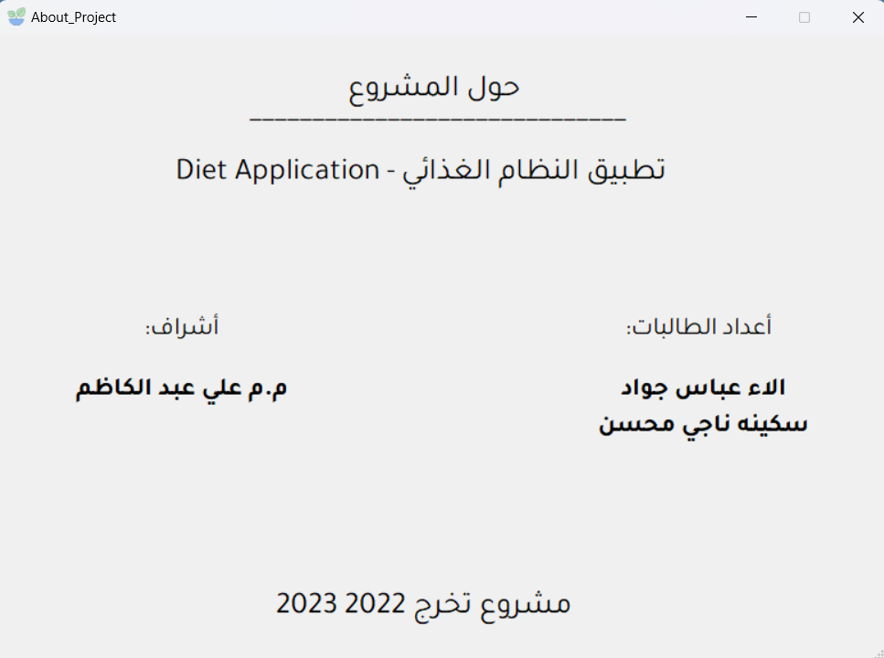

**Figure 26. About**

**4.9. User Dashboard:**

This window appears after the user’s login process. We note that all the buttons appear to move between pages, such as managing preferred and unfavorable meals, sports courses, nutritional courses, and user information such as weight.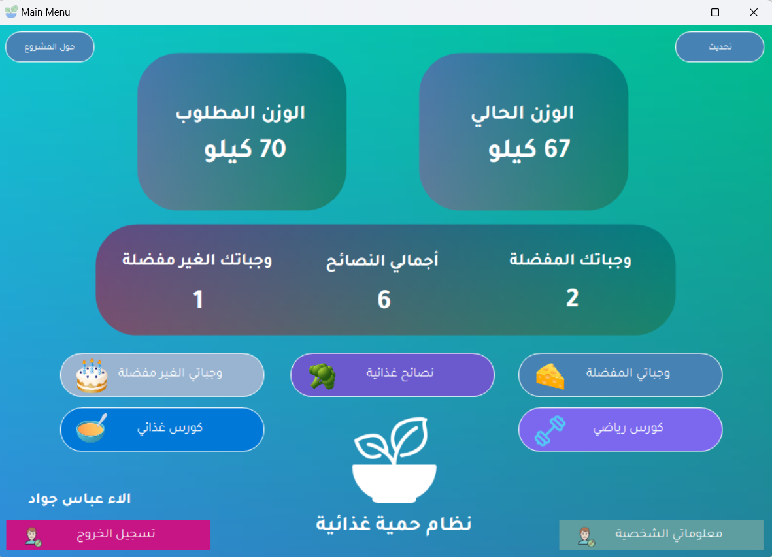

**Figure 27 . User Dashboard**

**4.10. Information:**

In this window, we notice that all user details appear and can be modified through the update button in the middle of the window, such as the user name, full name, gender, height, weight, required height, births, and body condition through the body mass measurement function, whether it is weak, fat, or medium.

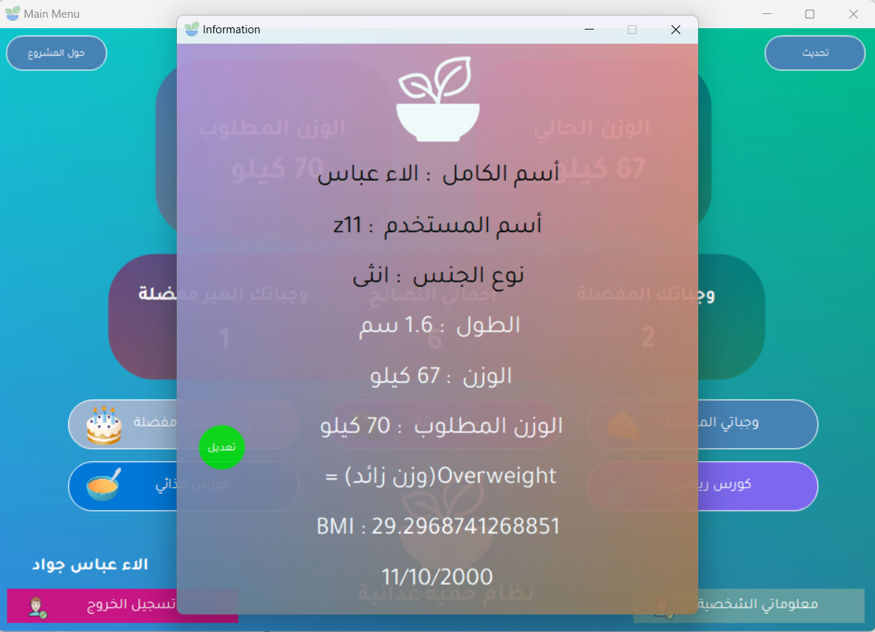

**Figure 28 . Information**

**4.11. Favorite Meals:**

We notice in this window that all the data of the preferred meals is managed, such as the name and type of the meal, and the meal is selected through the list of meals that appear in the drop-down list.

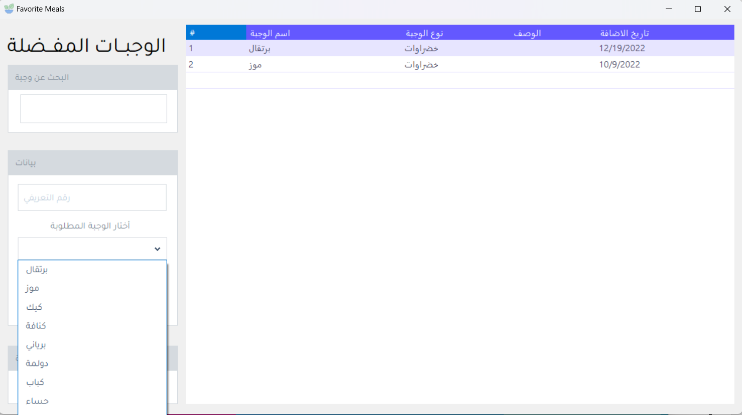

**Figure 29 . Favorite Meals**

**4.12. Dislike Meals:**

We notice in this window that all the data of the unpreferred meals is managed, such as the name and type of the meal, and the meal is selected through the list of meals that appear in the drop-down list (Combo Box from Tools Box).

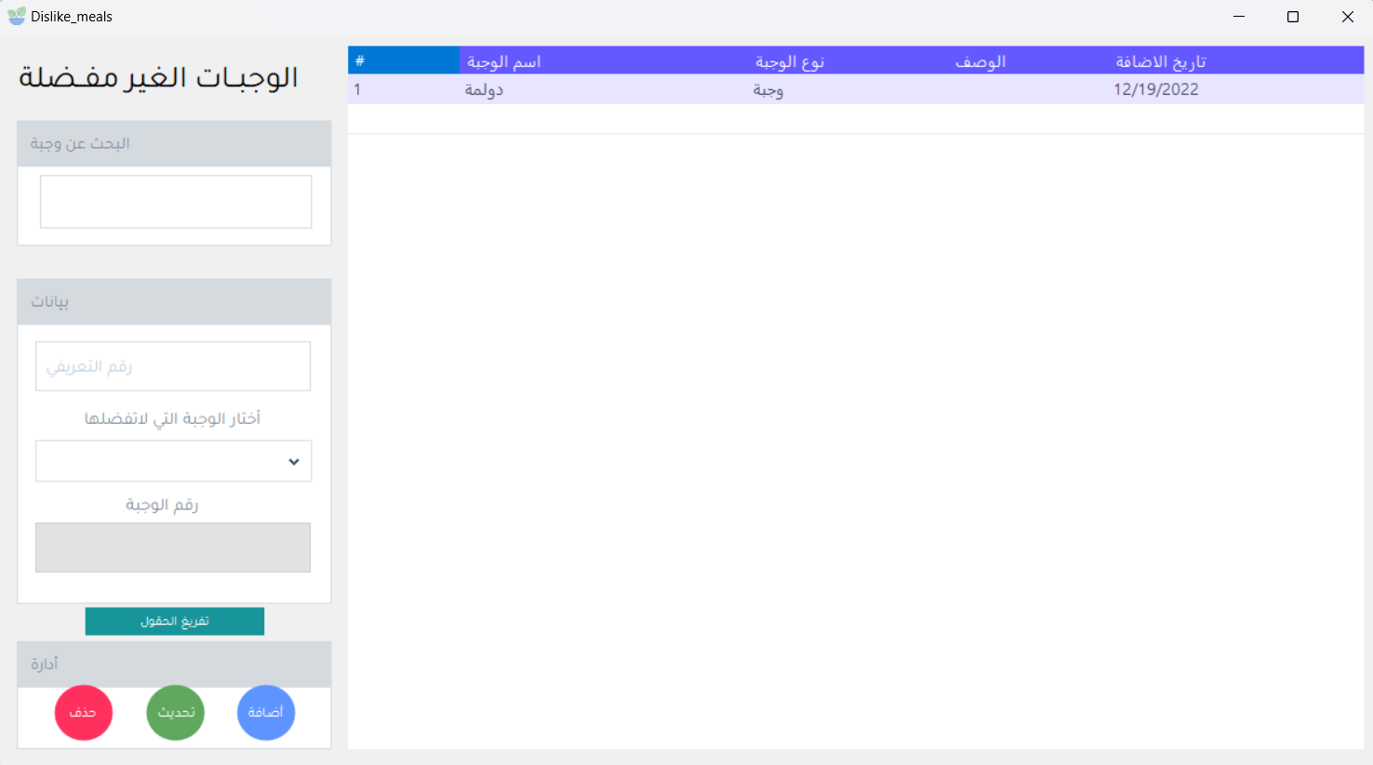

**Figure 30 . Dislike Meals**

**4.13. Tips:**

We note that in this window, available advice is displayed, such as the advice title, advice description, and date added, which were managed from the system control panel. 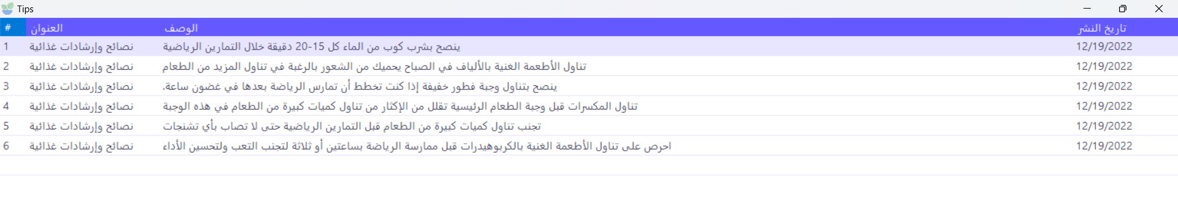

**Figure 31 . Tips**

**4.14. Exercise Course:**

In this window, the sports course is displayed, such as the name of the exercise, the body part, the frequency during the week, and the date of addition. 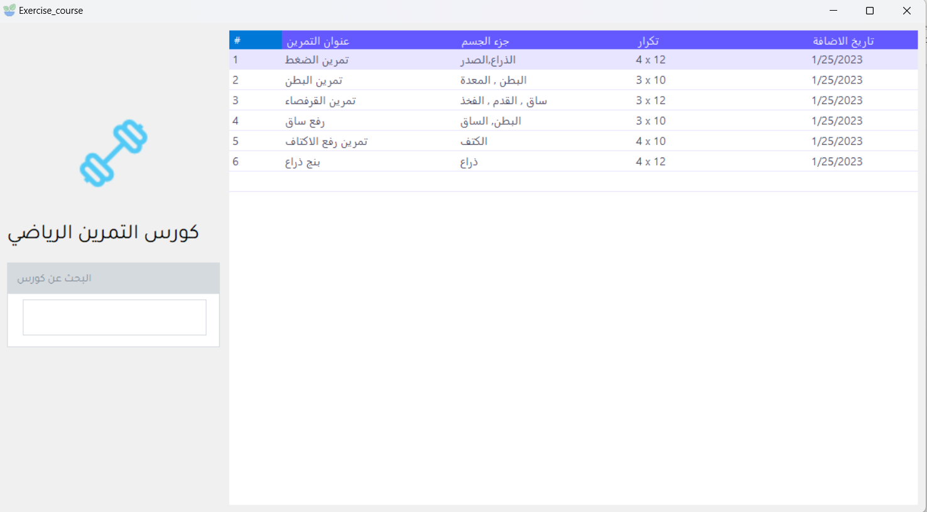

**Figure 32 . Exercise Course**

**4.15. Meals Course:**

In this window, the food course is displayed, such as the course title and description.

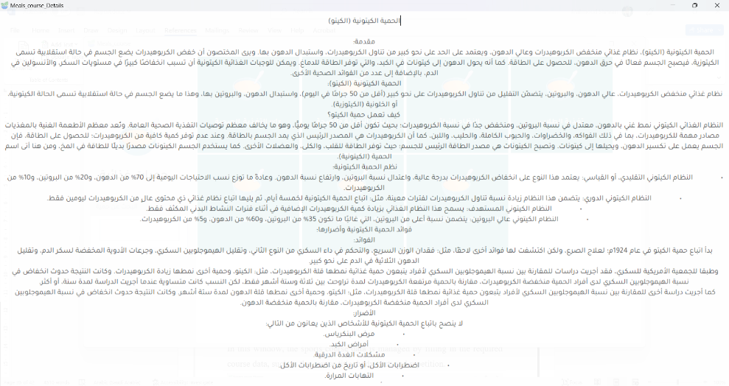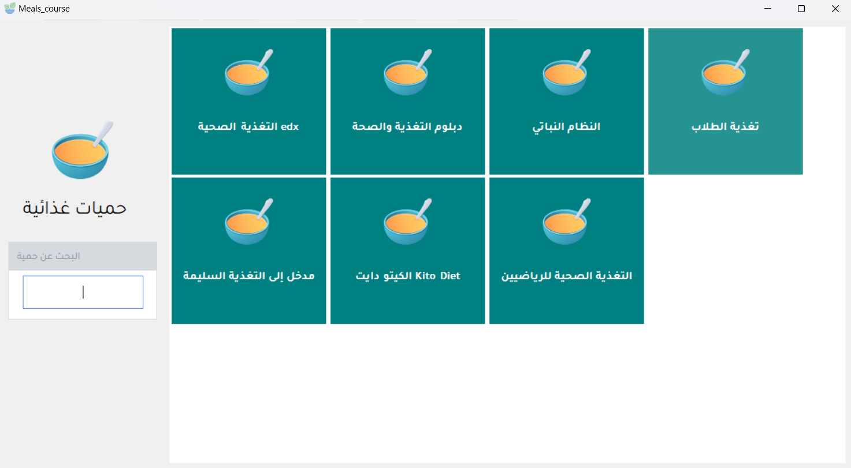

**Figure 33 . Meals Course**

Chapter Five

Conclusion and Future Work

## **Conclusion**

In conclusion, the goal of the project is to facilitate the process of maintaining human health by eating healthy and suitable foods for his body. In view of the great importance of health in human life, this project comes with a high status and deserves attention and study.

The complex application is one of the most important and useful projects in the world of technology and health. It works to improve human health and prevent various diseases by maintaining a balanced diet and proper nutrition. The application also offers many advantages to users by tracking the foods eaten, calculating calories, and providing nutritional guidance appropriate to the person’s condition and nutritional needs.

Accordingly, we conclude that this project has a promising future in the health and technology applications market, and it could be one of the essential steps in improving and preserving health. It is expected that this application will receive great interest from users who are interested in their health and healthy lifestyle, and therefore a great success can be expected in the future.

**Future Work**

The project can be developed using an API in the PHP language to create a mobile application and link it to the computer application. Flutter and Dart programming language can be used, for example, to create an application that works on the mobile operating system, Android and IOS, because it is a multi-platform and powerful programming language that is characterized by high speed, and data can be added to the application in an amount Great as food courses and meals.

References:

[1]. Mark Ryan, “The ethics of dietary apps: Technology, health, and the capability approach‏”, Wageningen University, 2022.

<https://www.sciencedirect.com/science/article/pii/S0160791X22000148>

[2]. Mirey Karavetian, “The Effects of Dietary Mobile Apps on Nutritional Outcomes in Adults with Chronic Diseases: A Systematic Review and Meta-Analysis”, 2019

<https://www.sciencedirect.com/science/article/abs/pii/S2212267218322731>

[3]. Madison Milne-Ives, Mobile Apps for Health Behavior Change in Physical Activity, Diet, Drug and Alcohol Use, and Mental Health.2020

<https://mhealth.jmir.org/2020/3/e17046>

[4]. Amanda Cuevas-Sierra, Diet, Gut Microbiota, and Obesity: Links with Host Genetics and Epigenetics and Potential Applications, 2019.

<https://academic.oup.com/advances/article/10/suppl_1/S17/5307226>

[5]. Abbie Fewings, “The use and acceptability of diet-related apps and websites in Australia”, 2022

<https://journals.sagepub.com/doi/full/10.1177/20552076221139091>